Sub phase -2 Technical stack
Date | 28-09-2026
Team ID | SWTID-2026-7624
Project name | Script-controlled ACL
Maximum marks | 4 marks

4. Technical Stack

The following technologies and components are used for implementing the Script-Controlled ACL project.

Component| Technology / Tool
Platform| ServiceNow
Access Control| Script-Controlled ACL
Programming Language| JavaScript
Database| ServiceNow Database
User Management| ServiceNow User & Role Management
Security| ACL / Role-Based Access Control
Testing| ServiceNow Impersonation
Data Table| Institution Details
Table Name| u_institution_details

Database Structure

The project uses a custom Institution Details table.

Table Label:

Institution Details

Table Name:

u_institution_details

Fields:

- Student Roll Number – Auto Number
- Student Name – Reference
- Faculty Name – Reference
- Branch – Choice (ECE, EEE, CSE)
- Email – String
- Phone Number – String
- Description – Multi-Line String

The Phase-1 design specifies these fields and the custom roles bb1, bb2, bb3, and bb4 for different CRUD permissions.

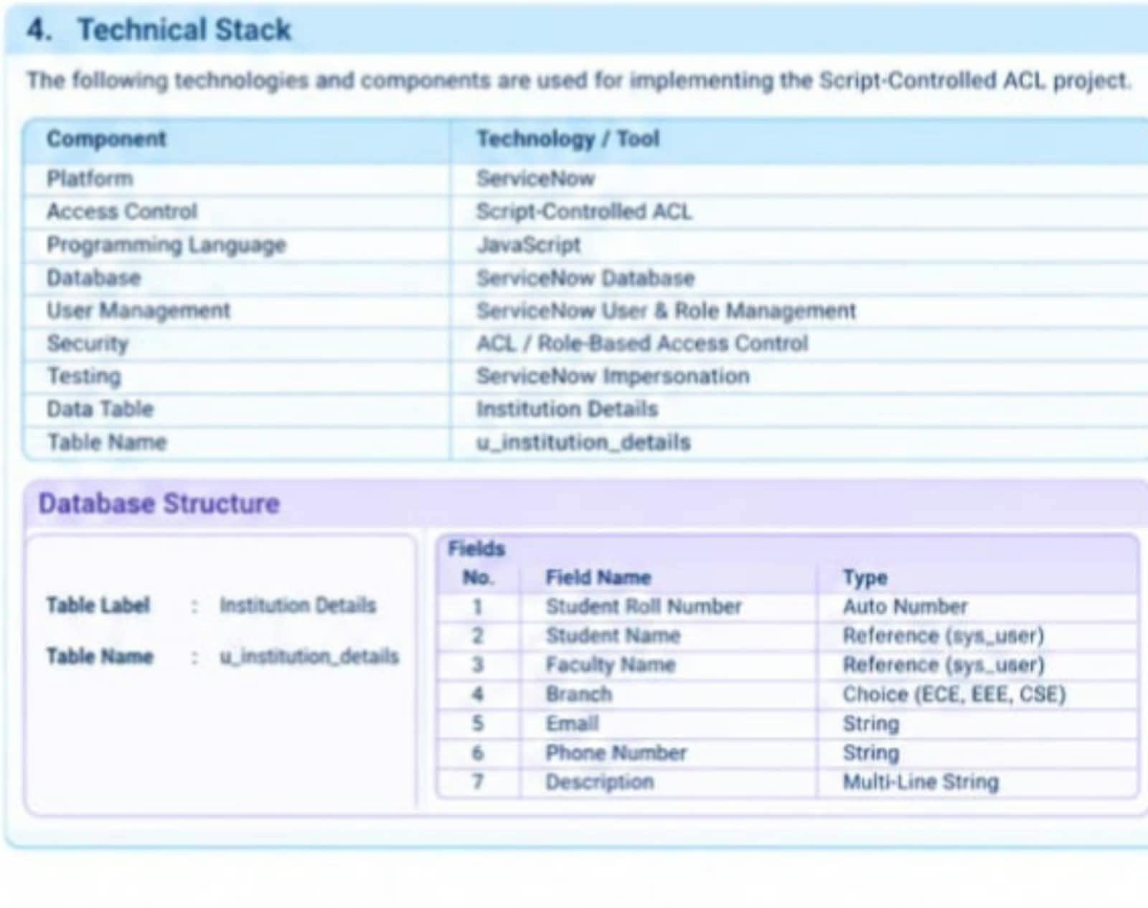

Conclusion

Phase-2 Requirement Analysis defines how the Script-Controlled ACL system will operate from the user's perspective and identifies the functional, non-functional, data-flow, and technical requirements.

The proposed solution provides controlled access to records by combining user roles with field-based access conditions. This approach provides more flexible and granular security than relying only on

